**TUGAS**

**PROGRAM JAVA 1**



**NAMA : FEBRI ARIANSYAH**

**NPM : 2016–804-298**

**KELAS : SI 5 B**

**DESIGN PROGRAM**

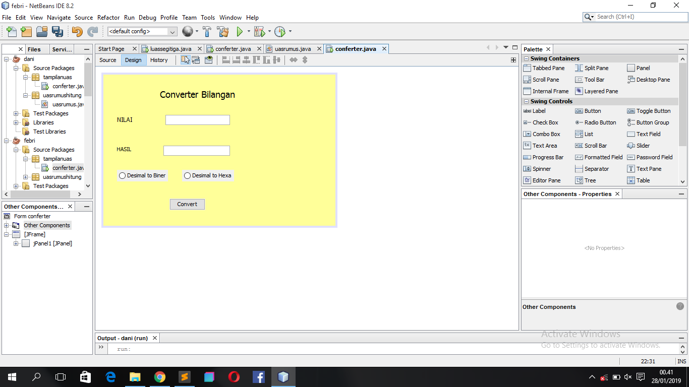

**RUNNING PROGRAM**

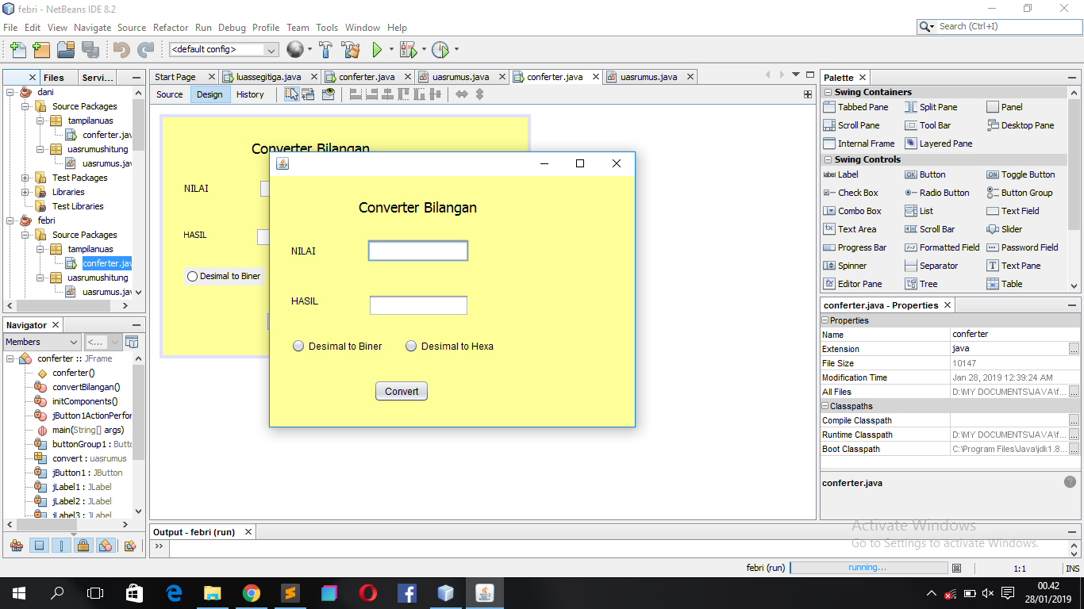

**RUNNING PROGRAM DESIMAL TO BINER**

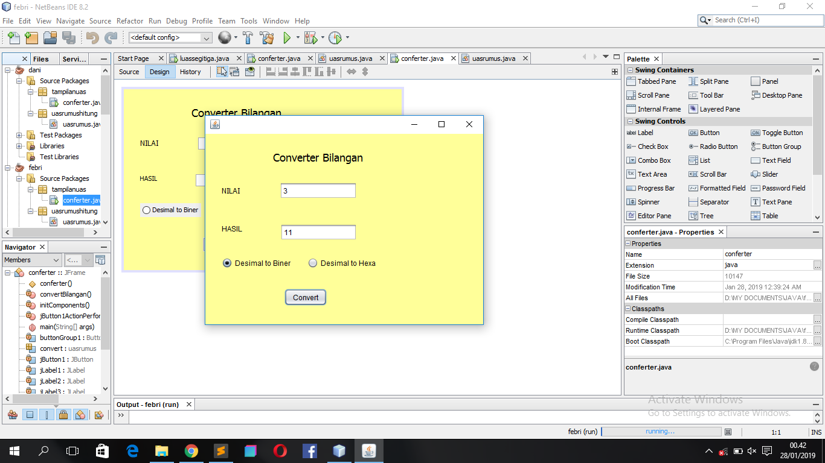

**RUNNING PROGRAM DESIMAL TO HEXA**

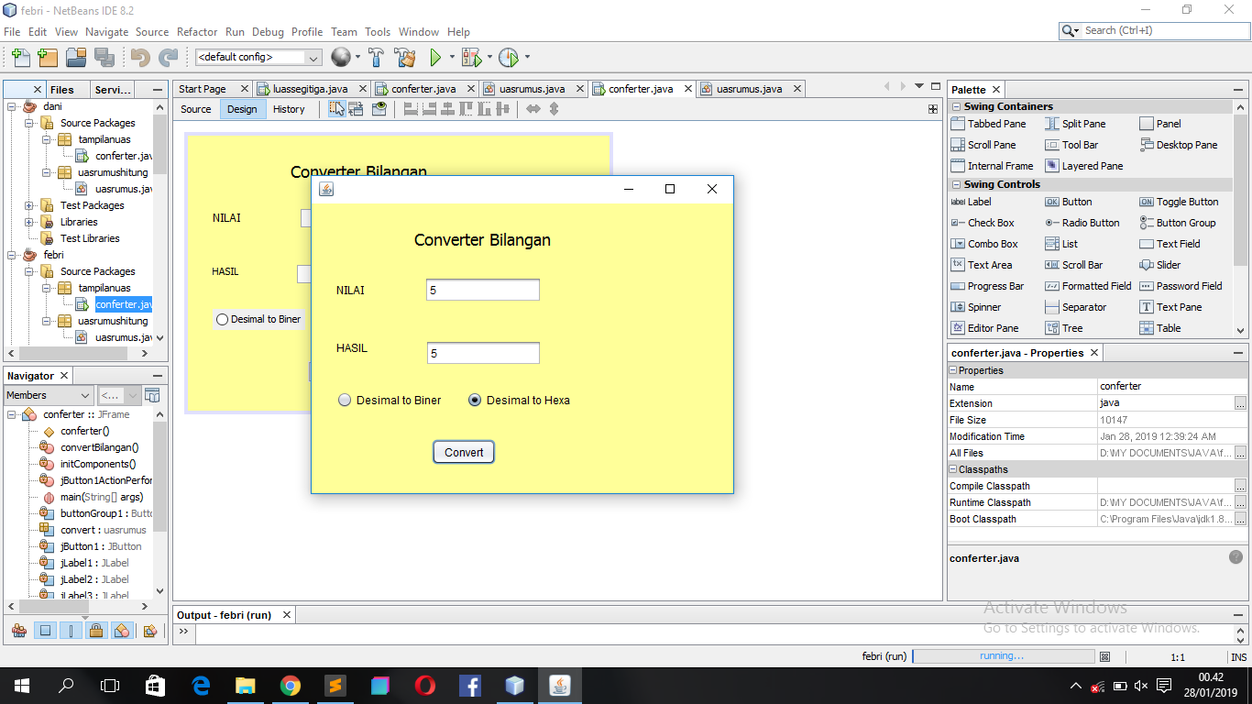

**SOURCE CODE DESIGN**

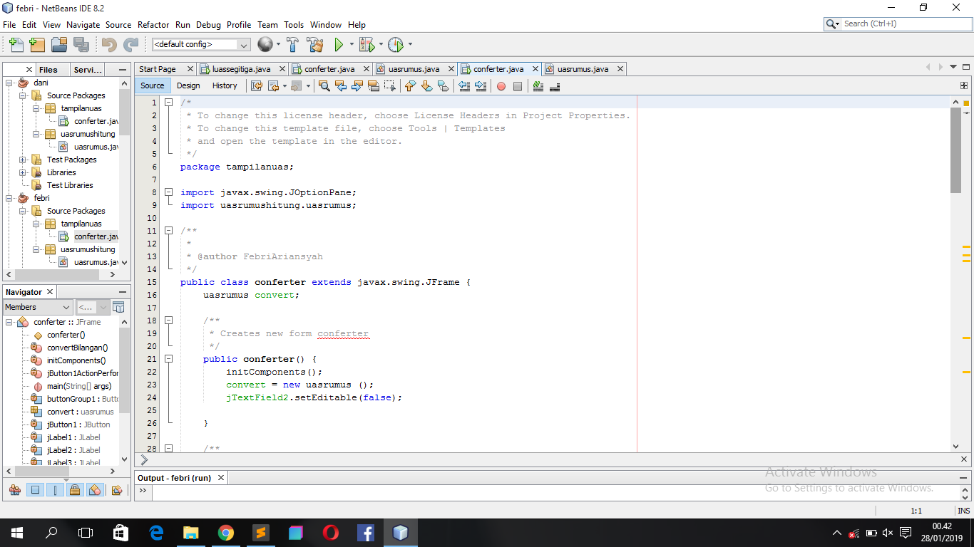

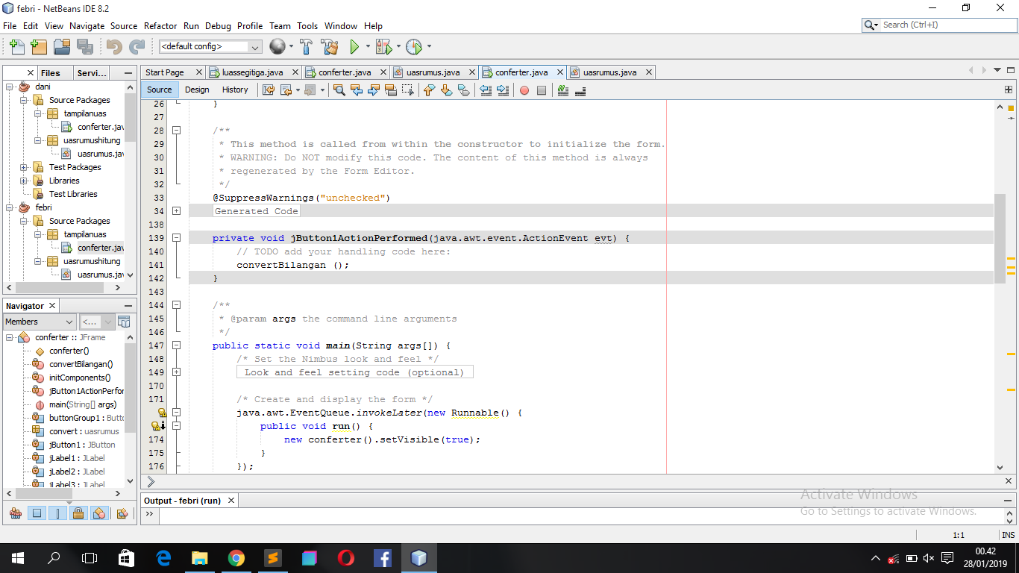

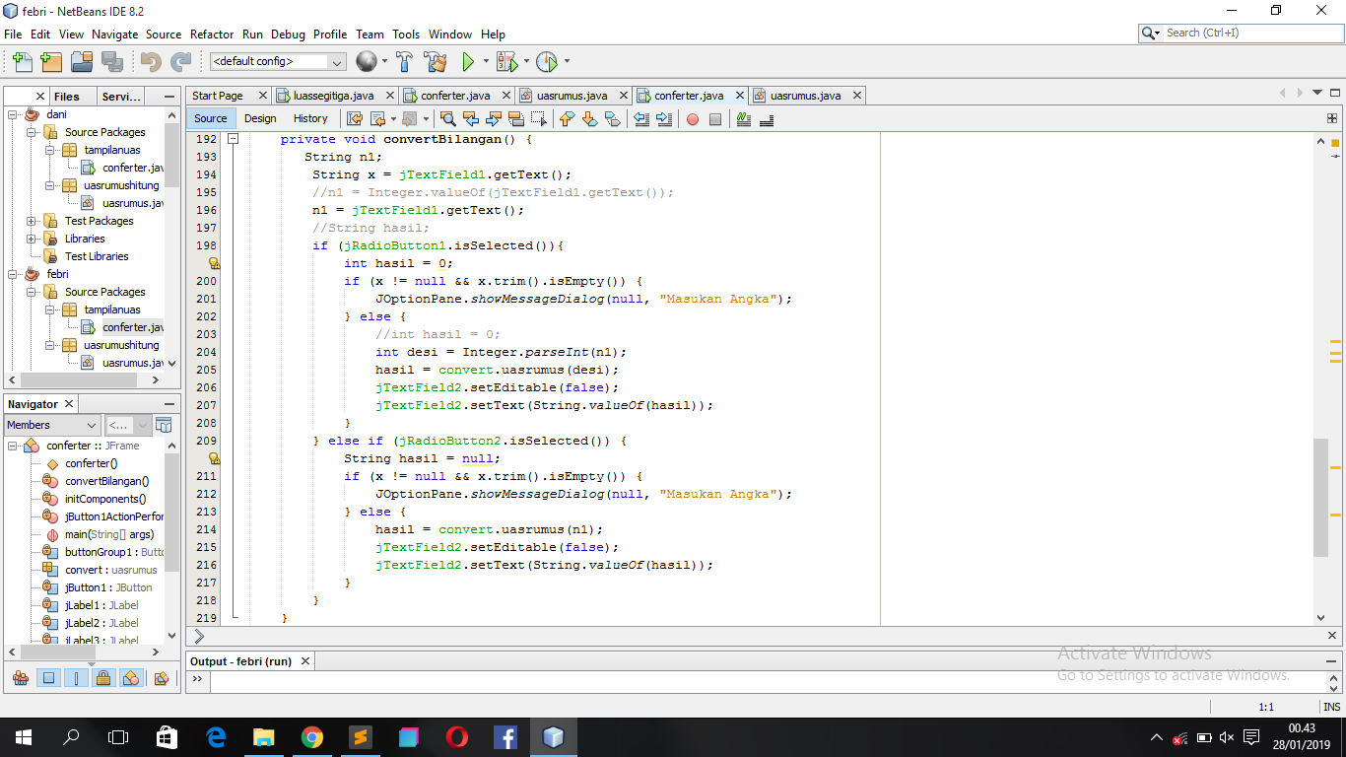

**SOURCE CODE RUMUS**

